DIS-Arc-Pipe pouch-Sioux-Lakota

Lakota Sioux, brain–tanned buffalo hide, beaded pipe pouch, 1840’s-1870’s. Length: 15 in. with fringe 25 in.; Width: 5 in. Interior lined with red trade velvet and exterior sewn with expensive red and dark purple trade glass beads in the form of the four sacred cardinal directions crossing at the holy center. Sewn with buffalo sinew. Grade 9 out of 10.  Unusual for this age with no bead loss. This suggests that this bag and its enclosed catlinite pipe and stem (both never conjoined unless used in a ceremony) were protected together with the band’s holy medicine bag. Excellent Provenance: from the Native American Collection of Ralph Edward Guy who was listed in Who's Who in American Indian Relics.

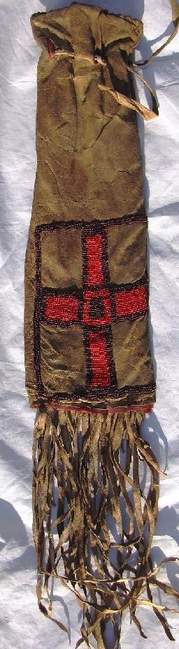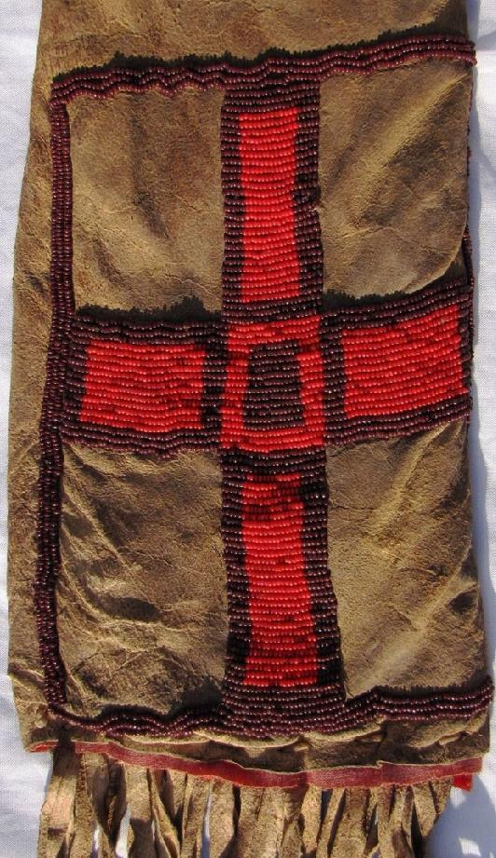

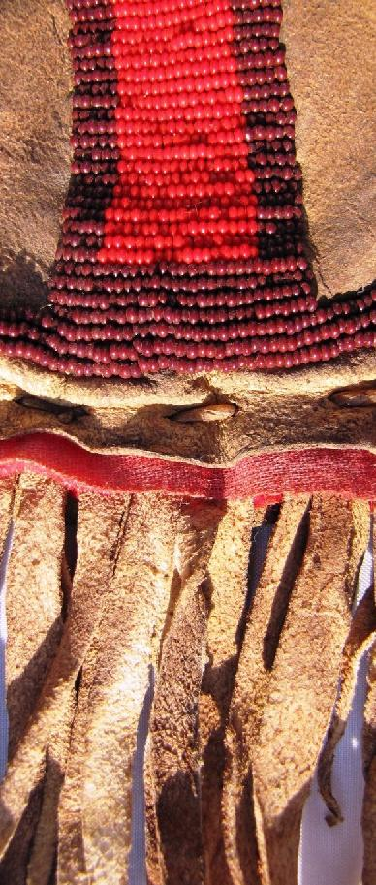

# Order details

## Sales order

Sold by [galleria-eleni](http://myworld.ebay.com/galleria-eleni) ( [866](http://feedback.ebay.com/ws/eBayISAPI.dll?ViewFeedback&userid=galleria-eleni) )

### Delivery package 1 of 1

Estimated delivery Tuesday, Apr 19, 2016 - Friday, Apr 22, 2016

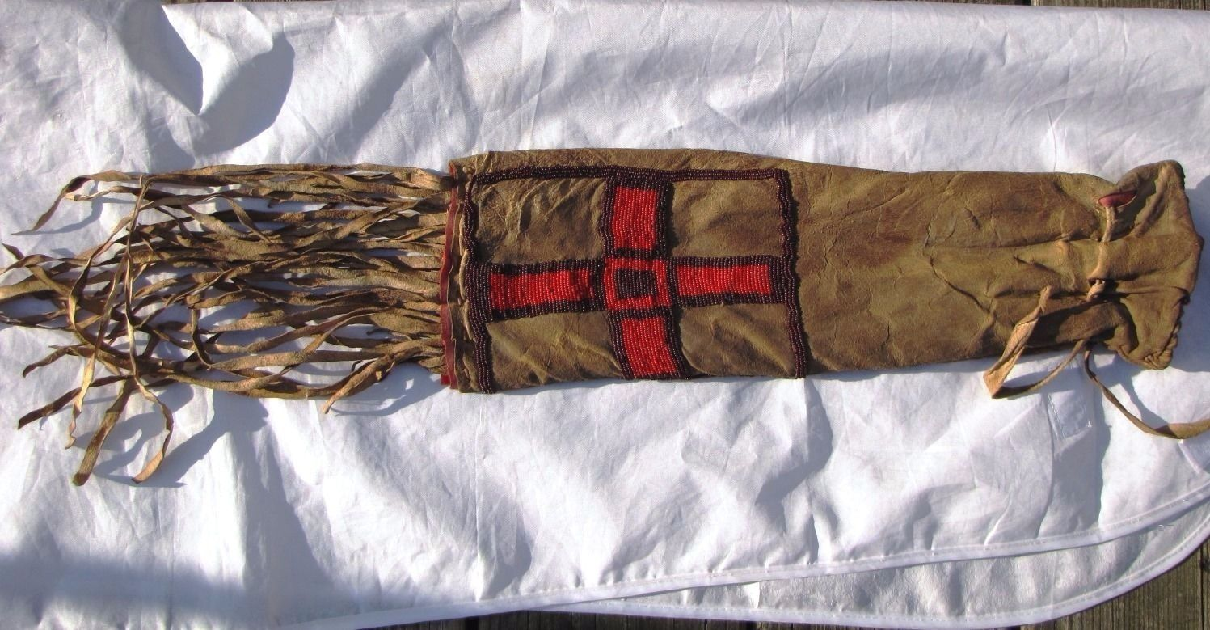

#### [1800's Native American Lakota Sioux Pipe Bag Sinew-Sewn Velvet Lined, Beaded](http://www.ebay.com/itm/131777796297)

|  |  |
| --- | --- |
| Item price | $499.80 |
| Quantity | 1 |
| Item number | 131777796297 |
| Shipping service | Expedited Shipping |

## Shipping address

Ralph J Coffman Jr

149 Atlantic Ave

Swampscott MA 01907-2427

United States

## Order total

|  |  |
| --- | --- |
| Subtotal | $499.80 |
| Shipping | Free |

**Total**

$499.80

Order placed on

Friday, Apr 15, 2016

Payment method

PayPal Credit

Payment date

Friday, Apr 15, 2016